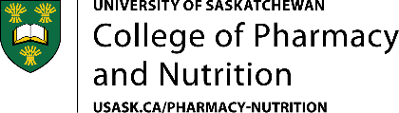

STUDENT PROGRESS UPDATE FORM

A Research Progress Meeting is required annually for program extension requests and scholarship eligibility unless a milestone committee meeting occurred within the past 12 months (e.g. Approval of Program of Study, Approval of Research Proposal, Preliminary Meeting/Candidacy Assessment, or Permission to Write).

Please complete this form and submit it to your committee prior to the meeting.

Name of Student:
Program and Start date:
Meeting Date, Time and Location:

SCHOLARLY PROGRESS
Since your last committee meeting, list any coursework, presentations and publications, and any professional development activities in progress or completed:

RESEARCH PROGRESS
Since your last committee meeting, describe your research progress and any challenges or concerns. In addition, briefly describe your research plans for the next 12 months.

